Here is exactly what each skill is for that project:
There is your complete 21-day Project 1 timetable — every single day has exact tasks, code snippets, and a clear output.
Five tabs to navigate:
- Day 0 — Setup — do this today before anything else
- Week 1 — ML model + SHAP (Days 1–7)
- Week 2 — RAG pipeline + FastAPI (Days 8–14)
- Week 3 — Streamlit UI + Docker + Deploy (Days 15–21)
- Daily Schedule — your fixed routine every day
The most important things to remember:
Day 1 is just setup and data download — no ML yet. This is intentional. Getting your environment right on Day 1 means zero wasted time on Days 2–21.
Day 4 is the hardest day — training the XGBoost model and understanding why F1 matters more than accuracy for fraud detection. If Day 4 confuses you, re-read it — this concept is the first thing every interviewer asks about fraud detection projects.
Day 19 is the most exciting day — your app goes live on the internet with a real URL. This is the moment it becomes real.
Day 21 is when you post on LinkedIn and start applying. Do not skip this — the LinkedIn post alone has gotten people recruiter messages within 24 hours in 2025.
Start with the Day 0 Setup tab right now. Everything you need before Day 1 is listed there. It takes 2–3 hours. Do it today and you start Day 1 tomorrow morning.

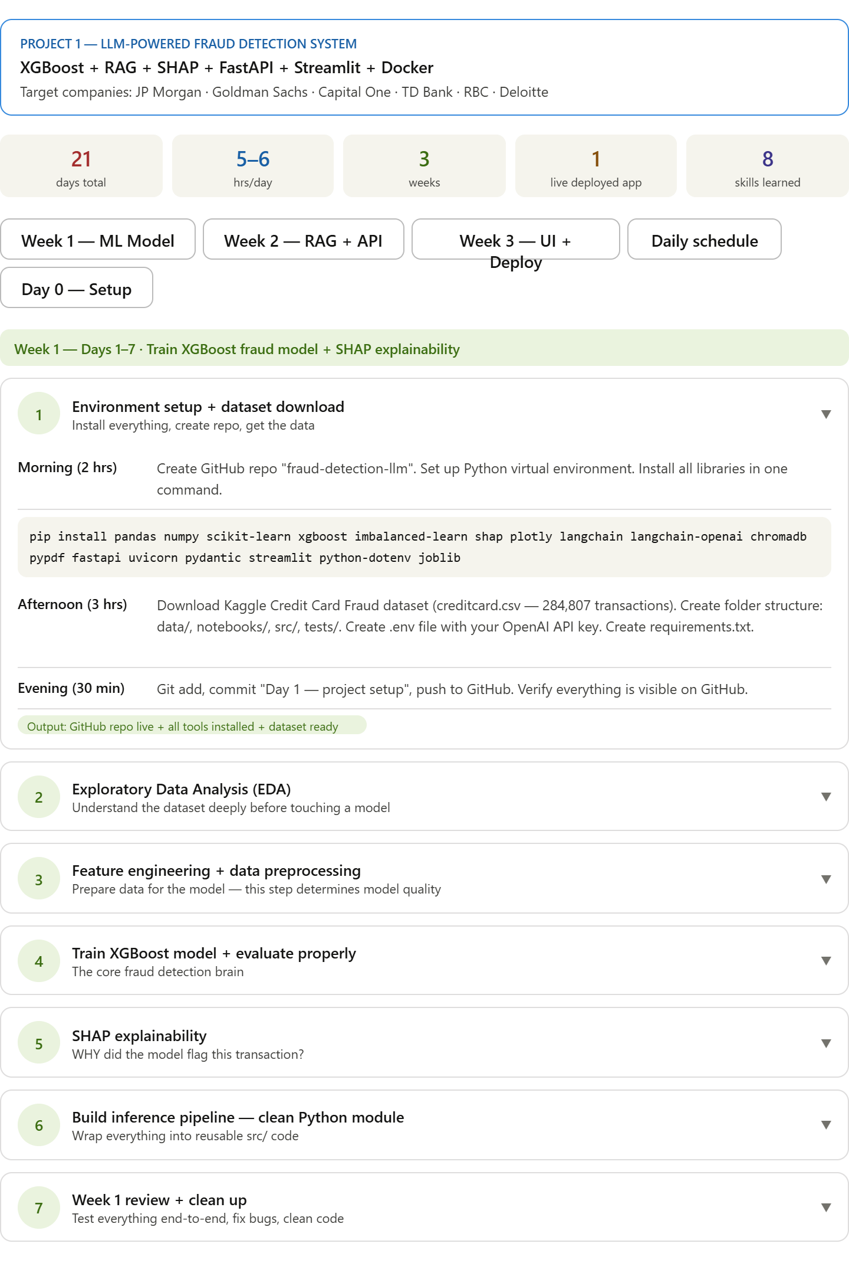
Skill | What it is
Skill 1 | Python — foundation of everything
Skill 2 | XGBoost + Scikit-learn — train the fraud detection model
Skill 3 | SHAP — explain why the model flagged a transaction
Skill 4 | LangChain + RAG — retrieve regulatory explanations (FATF/FinCEN docs)
Skill 5 | ChromaDB — store and search document embeddings
Skill 6 | FastAPI — expose the model as a REST API endpoint
Skill 7 | Streamlit — the visual web app recruiters will demo
Skill 8 | Docker — package everything for deployment

So the complete picture for Project 1 only is:
- 3 weeks to build
- 8 core skills to learn
- 14 tools/libraries to install
- 5–6 hours/day commitment
This was specifically generated earlier in our conversation when you asked "give me project 1 skills list — how much time will it take, all tools and skills required?"
The full day-by-day plan (all 21 days), the tools install command, and the start-from-zero guide are all in that widget — you can scroll back up to find it or I can regenerate it.
